My MBTI Type is ___________
List 5 Phrases you highlighted from your report
1.
2.
3.
4.
5.
Identify 2 Items about communication with your type
1.
2.
Identify 2 items regarding your type and managing conflict
1.
2..
Identify 2 items regarding your type and making decisions
1.
2.
Identify 2 items regarding your type and managing change
1.
2.
MBTI Resource: 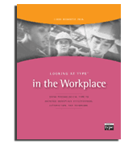Looking at Type in the Workplace by Larry Demarest

